Introduction to HANA KG
- SAP HANA Cloud offers a Knowledge Graph (KG) capability that enables the creation, management, and querying of graph-based data models within the HANA ecosystem.
- Offers a powerful, built-in mechanism to represent complex, interlinked data using semantic relationships.
- Model’s data as entities (nodes) and relationships (edges)—ideal for representing rich, interconnected data.
- Leverages SAP HANA's in-memory processing and graph algorithms to handle large-scale graph data efficiently.
- Supports SPARQL, the industry-standard language for querying semantic data.
- Designed for use cases requiring deep insights, relationship reasoning, and context-aware data exploration.

Business Use Case Samples
SAP Knowledge Graph can be implemented across multiple business areas, such as supply chain management, customer relationship management (CRM), finance, and human resources (HR).
In supply chain management, SAP Knowledge Graph can be used to trace relationships between suppliers, production facilities, logistics partners, and customers. This enables real-time monitoring of disruptions, more accurate forecasting, and proactive decision-making, which are vital for maintaining business continuity in global supply chains.
In healthcare, data interoperability is critical for ensuring that patient records are shared efficiently between providers, insurers, and laboratories. SAP Knowledge Graph’s ability to map relationships between different entities and data sources makes it a powerful tool for improving patient care and operational efficiency.
Key Terminologies
- Triples: The fundamental unit, consisting of (subject, predicate, object), representing facts.
- RDF Support: SAP HANA Knowledge Graph stores data using the RDF (Resource Description Framework) standard, facilitating interoperability and semantic richness.
- SPARQL Queries: You can query the graph data using SPARQL, a standardized query language for RDF data.
- Ontologies: SAP HANA supports OWL ontologies to define vocabularies and rules, enabling advanced inference and validation.
- Integration: The graph store integrates seamlessly with SAP HANA’s relational and analytic engines, enabling hybrid queries.
- Semantic Data Modeling: Represents data as nodes (entities) and edges (relationships), enabling rich, flexible modeling beyond traditional tables.
- High Performance: Leverages SAP HANA’s in-memory engine for fast, scalable graph processing and querying.
- Standards-Based: Supports SPARQL and Cypher for powerful semantic and property graph queries.
- Integrated & Unified: Seamlessly blends with relational and document models within SAP HANA, eliminating data silos.
- Enhanced AI & Analytics: Adds semantic context to data, improving machine learning, reasoning, and reducing AI hallucinations.
- Data Integration: Unifies diverse data sources, enabling a connected view of enterprise information.
- Cloud-Native & Secure: Enterprise-grade security, elastic scalability, and native support in SAP HANA Cloud.
- Enhanced Data Integration: Knowledge Graphs unify diverse data sources in HANA Cloud, linking related entities to provide a holistic and connected view of business information.
- Improved Context and Semantics: By capturing relationships and meanings, Knowledge Graphs add rich context to raw data, making analytics and queries more meaningful.
- Flexible and Scalable Modeling: They enable flexible data models that easily adapt to changing business requirements without rigid schemas, ideal for dynamic enterprise environments.
- Advanced Analytics and Insights: Knowledge Graphs support complex queries, reasoning, and inference in HANA Cloud, helping businesses discover hidden patterns and new knowledge.
- Better Support for AI and Machine Learning: The semantic structure of Knowledge Graphs enhances machine understanding and improves the performance of AI models running on HANA Cloud.
- Reduction of Data Silos: By connecting isolated data points across systems, Knowledge Graphs break down silos and improve data consistency and accessibility within HANA Cloud.
- Improved Decision-Making: Richly interconnected data empowers organizations to make faster, smarter decisions based on a comprehensive understanding of their data.
- Performance: Leverages SAP HANA’s in-memory computing power for fast traversal and querying of complex graphs.
- Unified Platform: Integrates graph data processing with existing HANA SQL and analytics capabilities, removing silos.
- Enterprise-Grade Security: Benefits from HANA’s robust security model including data encryption, user authentication, and role-based access.
- Multi-Model Support: Supports not only graph but also relational and document data within the same platform.
- Cloud-Native Scalability: Runs efficiently on SAP HANA Cloud, supporting scalable, elastic cloud infrastructure.
- Transforming Raw Data into Practical Knowledge: Raw data alone lacks context. HANA KG adds meaning and semantics, turning data into actionable, practical knowledge.
- Enabling True Machine Understanding: For machines to make intelligent decisions, they must interpret, reason, and act upon knowledge. HANA KG supports this by providing rich, interconnected data representations.
- Modeling Complex Business Domains: Business environments are diverse and intricate. Graph structures within HANA KG naturally capture these complex relationships and dependencies.
- Reducing AI Hallucinations in Business Applications: Unstructured language models often generate inaccurate outputs (hallucinations). Incorporating structured knowledge graphs helps ground AI models, improving reliability.
- Supporting Advanced Reasoning and Inference: Logical reasoning over graph data enables the discovery of new insights and knowledge, essential for decision-making and innovation.
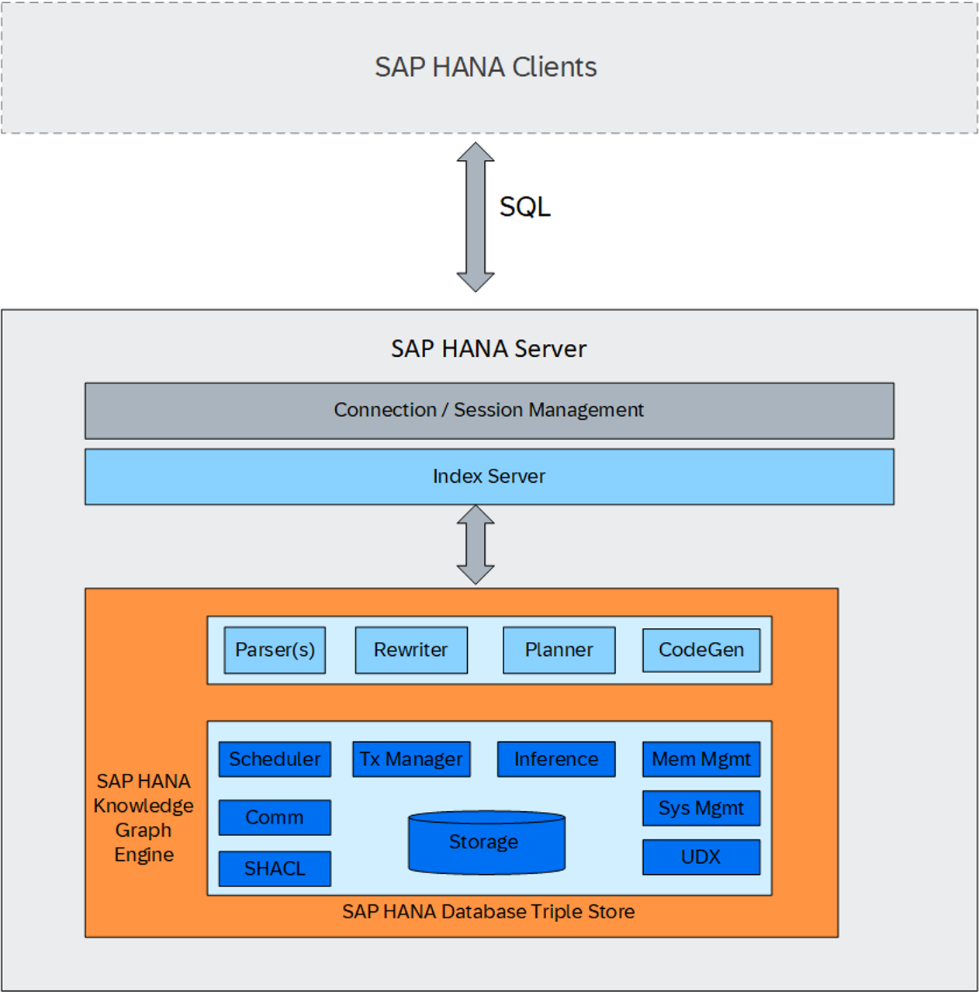

RDF (Resource Description Framework)
- RDF represents the relationship between data across different sources using triples via shared vocabularies.
- It consist of a subject, a predicate, and an object.
- SAP HANA Cloud’s RDF functionality generally allows for importing and exporting RDF data in the below format
Turtle (.ttl)
RDF/XML (.rdf / .xml)

TRIPLES:
A triple in RDF is a data structure that consists of three components: subject, predicate, and object
- All three components of a triple are represented by Uniform Resource Identifiers (URIs).
- URIs are of two types - Standard and custom
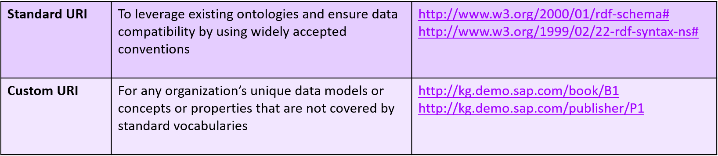
TURTLE
- Turtle (Terse RDF Triple Language) is a concrete syntax and is a textual representations of an RDF graph defined by W3C.
- It's used to define entities (nodes) and their relationships (edges) in a Knowledge Graph.
- It serializes RDF data in a human-readable and easy-to-write format.
- Supports compact URIs via prefix.
- Turtle files can be created manually with a text editor or via Python / Java.
- Below is a sample ttl file generated via a code written from Python
Each line in a Turtle file represents a fact (triple):
- Subject: the entity (e.g., a book or author)
- Predicate: the property or relationship
- Object: the value or another entity
Typing and Classification in Turtle
Turtle uses standard vocabularies to type/classify entities:
- rdf:type → denotes class/type
- rdfs:label → gives a human-readable name
- SPARQL (SPARQL Protocol and RDF Query Language)
- SPARQL is a standard query language for RDF databases. It allows users to retrieve and manipulate data by matching patterns in the RDF graph.
- SAP Hana cloud is a SQL DB and access to SPARQL is handled by a build in procedure and build in table function
- SPARQL_SELECT
- A SPARQL SELECT statement is used to query RDF data by selecting specific variables and patterns.
- Variables represents parts of the triples, and a WHERE clause is defined to match the pattern.
- SELECT ?variable1 ?variable2
- WHERE {
- ?subject ?predicate ?object .
- # Additional patterns or filters can go here
- }
- Most SPARQL statements resemble SQL statements, but there are a few constructs unique to SPARQL like
- OPTIONAL - Allows for the specification of optional patterns that may or may not be present in the graph.
- FILTER - Allows for the specification of optional patterns that may or may not be present in the graph.
- ONTOLOGIES
- Ontologies define high-level concepts and relationships in a domain.
- They provide structure and meaning, acting as a blueprint for organizing knowledge graphs.

Graph:
- RDF Graphs (Resource Description Framework) Supports semantic web standards, enabling interoperability with linked data and ontologies.
Supported File Formats for Import/Export
- RDF/XML - Standard XML format for RDF which is widely supported.
- Turtle (.ttl) - Standard formats for RDF graph data interchange which is human readable.
- N-Triples (.nt) - Standard simple, line-based and is best for debugging or basic import/export.
- JSON-LD - JSON-based linked data format, widely used for web data.
Interoperability and Tools
- RDF libraries (like Apache Jena, RDFLib, or rdflib.js) can read, write, and convert between these formats.
- SPARQL can query both single RDF graphs and datasets with named graphs.

